Climate Action Pod
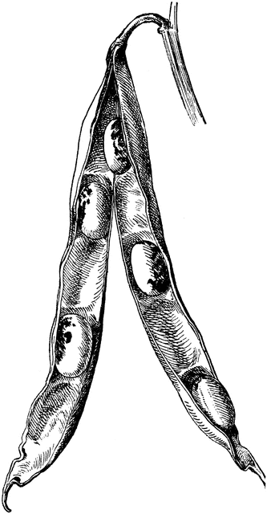
What is it?
A group of interested and engaged graduate and undergraduate students who are exploring interlinked topics related to climate action & adaptation both individually and in teams. We will have at least one social event per semester and a required monthly meeting. We will also foster a learning community via in-person and web-based interfaces.

What will you gain?
- Opportunities to:
          - learn about climate action & adaptation
          - conduct independent & joint research
          - be a primary or co-author on papers
          - attend at least one professional conference/year with colleagues
          - gain additional funding for your research
          - participate and lead other professional development opportunities
- A small stipend for contributing to the work of the group
          - Undergraduates: $1,000/semester ($13/hour)
          - Graduate students: $2,500/semester ($18/hour)
- A network of like-minded peers
- Personal mentoring for your time at UWYO and for your career

What will you contribute?
- Your passion and interest
- Commitment to at least one-year in the “pod”
- Significant contribution towards at least one paper
- Attendance at regular monthly meetings and social events
- At least 1 post per week online
- For undergraduates: At least 4 hours on project-related work a week ($13/hour)
- For graduate students: At least 7 hours on project-related work a week ($18/hour)

How to Apply:
- Send your resume, names/numbers of two references, and a cover letter expressing your interest to corrie.knapp@uwyo.edu by September 20th. Please title the email “Climate Action Pod”.

